**Wind Turbine Lab Report**

**Submitted to:**

Annie Abell

Russ Stech

**Created by: Team Z**

Cody Allison

Eric Marko

Danielle Meyer

Monica Okon

Engineering 1181.01

The Ohio State University

Columbus, OH

15 November 2014

# Executive Summary

The Wind Turbine Lab introduced concepts of velocity and pressure, and how they relate to power generated by wind. The first half of the lab addressed the relationship between wind, velocity, and voltage as well as the relationship between the radial position and wind velocity. By varying the radius of the Pitot Tube, the location with the highest wind velocity was found, for each respective voltage, which was determined to be found along the inside wall of the tube. The wind velocity was then recorded starting at 6 volts and up to 12 volts, in increments of 1 volt, and then used to determine the calculated power output for each situation. Higher voltage resulted in higher velocity which resulted in more power being generated.

In the next task, the relationship between the number of blades and wind velocity was investigated. A two and three-blade turbine were both tested and it was discovered that the three-blade turbine was producing more power; the two-bladed scenario produced 12 watts while the three-bladed one produced 16 watts.

In the latter half of the lab, the team examined the difference between the 30 and 45-degree hub as well as different blade designs. Each member designed their own blade and the design that produced the most power was duplicated into a complete set of blades. The new set of blades were then tested using 30 and 45-degree hubs. The 30-degree hub produced more power with 17 watts compared to the 8 watts produced by the 45-degree hub.

One obstacle faced in this lab was that the designed blade continuously fell off the hub when tested at high voltage. This created difficulties in measuring the wind velocity of the blades and required excessive trials to record data. However, this was solved by modifying the shape of the blade in order to better fit the hubs.

Overall, the team gained insight and understanding among velocity, pressure, and wind turbine blades throughout this lab. Based on the data in this report, the 50KWH turbine is enough to power the residential complex.

# Table of Contents

Executive Summary 2

Table of Contents 3

Introduction 4

Experimental Methodology 4

Results 6

Discussion 11

Appendix 12

# Introduction

This purpose of the Wind Turbine Lab report was to become familiar with characteristics of wind tunnels, turbines, fluid mechanics, and Bernoulli’s equation. In addition, the relationship between velocity and pressure as well as the conversion of wind energy to electrical energy were observed. In order to become familiar with these topics, the wind velocity was measured at different radii and different voltages as well as with varying number of blades on the turbine (two and three). This report contains the methods used and results obtained that enabled the recommendation to be made to the residential complex.

# Experimental Methodology

In this experiment, a mini wind tunnel was used. The lab setup can be seen in Figure 1 on the next page. After familiarizing with the lab setup as found in the Wind Turbine Lab documentation, the wind velocity was measured in the mini-wind tunnel. The wind speed profile at varying speeds was found by setting the velocity at 6, 9, and 12 volts and moving the pitot tube radially. Further data was taken at the center of the wind tunnel while varying the power supplied, in order to find wind power and flow rates.

In the following steps, a propeller was placed in the wind tunnel and the power output was measured. The setup can be seen in Figure 2 on the next page and was performed with two types of blades, with 2 and 3 propellers. After this, each engineering in the group designed their own propeller and each was tested in a similar fashion. Using the most effective blade, it was then tested using different numbers of blades. Lastly, the pitch of the blade was tested by varying the angle using the given hubs.

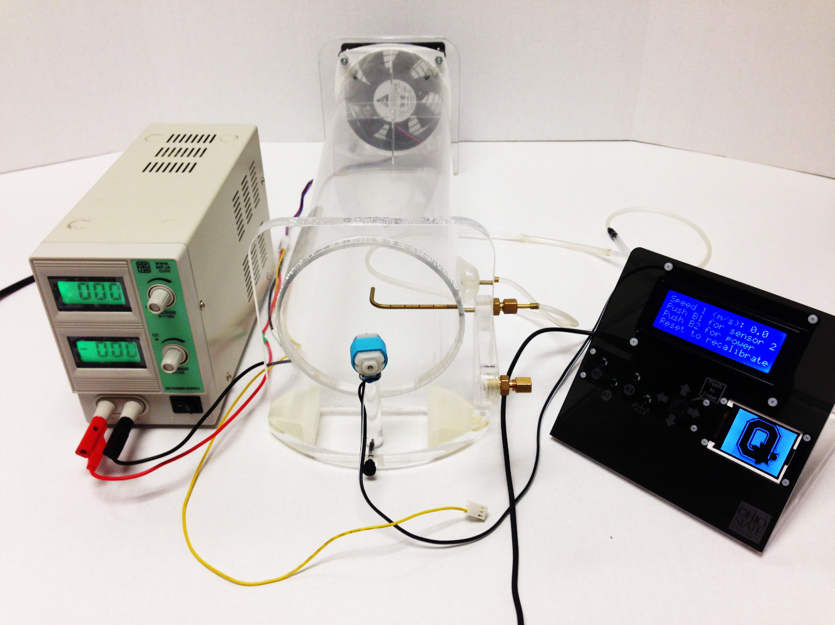

Wind Tunnel

18V DC Power Supply

Display Panel

Pitot Tube

Figure 1: Wind Tunnel Experimental Setup

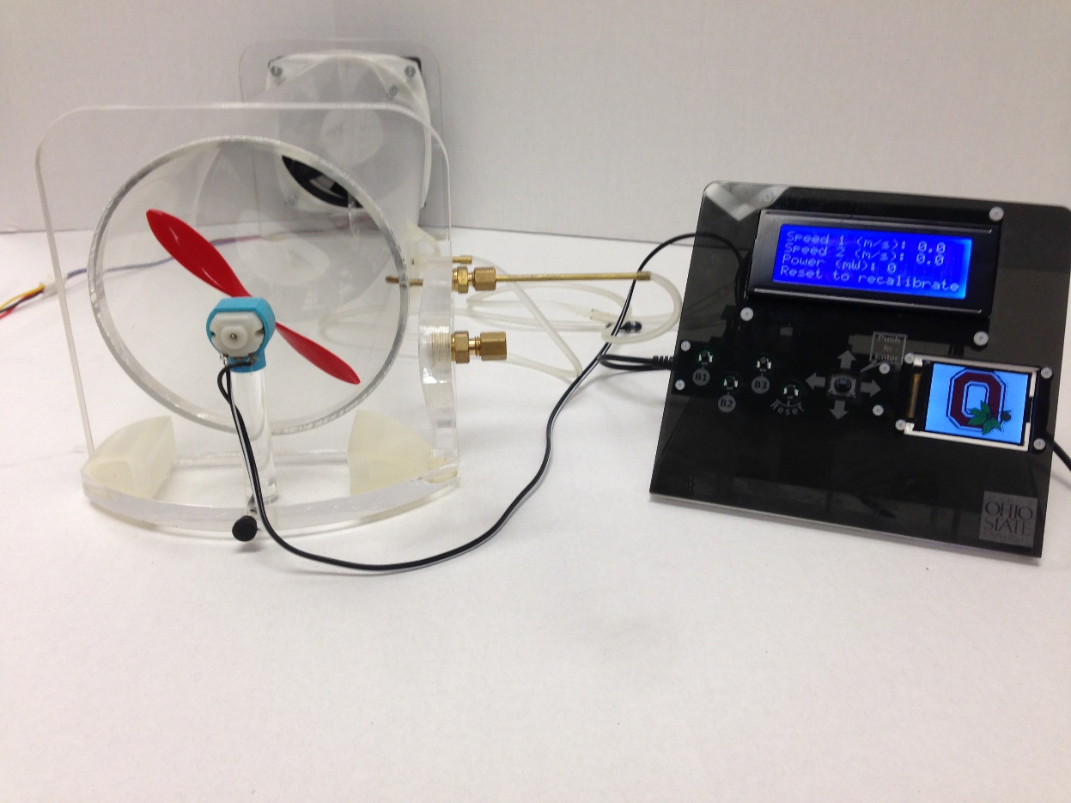

Figure 2: Wind Tunnel Setup with Propeller

# Results& Discussion



**Table 1**

Table 1 shows the changes in wind speed, in meters per second, as the Pitot tube moves in centimeter increments away from the center of wind tunnel cylinder. Also shows the calculated pressure difference, in Pascal’s, given by the formula (ρ(kg/m^3)*(Wind Speed)^2 (m/s))/(2).

**Figure 3**

Figure 3 portrays the variation of wind velocities based on radial position, varied by adjusting the Pitot tube, within the wind tunnel cylinder.



**Table 2**

Table 2 shows the change of the area of affected area being measured by the Pitot tube. This table also shows the calculated wind power, in watts, of the different wind speeds, at three different levels of voltage, and different measurements of the Pitot tube relative to the center of the wind tunnel center.

**Figure 4**

Figure 4 demonstrates the effect that radial position has on pressure for three different voltages.

**Figure 5**

Figure 5 exemplifies the changes in wind power harnessed from different radii, given the same three different voltages.



**Table 3**

Table 3 shows the change in wind velocity, meters per second, of the wind as the voltage was increased by increments of one. After this data was recorded it was used to find power generated by the blades with the formula ((0.5)*ρ*A*v^2), volumetric flow rate with the formula (Wind Velocity)*(Area), and the mass flow rate with the formula (Volumetric Flow Rate)*ρ.



**Table 4**

Table 4 compares the power output, in watts, between the two blade design and the 3 blade design with the change in wind velocity, which was recorded in the Table 3.



**Table 5**

Table 5 shows the power output of the blades designed by the group with fan motor running at 12 volts.



**Table 6**

Table 6 shows the power output of the most efficient blade designed by the group as the number of blades is increased. The blade that was used for this was wide at the base, where the blade is stuck into the hub, and decreases in width continuously till the tip of the blade.



**Table 7**

Table 7 compares the power output, in watts, of the blade design between the two hubs, one with its pitches at 30 degrees, and the other at 45 degrees.

Below is the first discussion question.

Location: Cleveland

Wind speed = 6.0 m/s

D=1.29 kg/m^3

A=pi*(32m)^2

Total Power Necessary= 40 Houses*50KWH/Day=2000 KWH/Day

Power=.5*(Density of Air)*(Area)*(velocity of air)^3*Efficiency*24hrs/day

P=.5*(1.29kg/m^3)*(pi*1024m^2)*(216m^3/s^3)*.25*24 hrs=2689146.96

W=2689.15 kWH/day

This turbine can power the entire residential complex with some energy to spare. Based on our online research, a 1MWH can power 240-400 homes (www.tradewindenergy.com). While the number above is plausible, it seems like a low number of homes.

**Conclusion & Recommendation – Cody Allison**

The Wind Turbine Lab that was conducted is an excellent example of how the labs performed in our class can represent real life engineering problems with practical approaches and solutions to these problems. In this specific lab, we studied wind turbines, tested the power of wind tunnels, and then were able to design our own wind turbine blades and test them and their efficiency. The first thing that we were required to do was test the power output from the fan when powered by certain voltages. We tested and recorded the power when the sensor was in one of six radii positions; this was lab 7a, and the data regarding these tests is shown in the first chart displayed below the results above. One problem that corresponds to this data was our initial attempt to record the data that came from the first tests. When we started recording the data, our numbers were off due to neglecting to calibrate the arduino board. If we had payed attention to this, we could have potentially saved time and not have been distracted by our mistakes. We could have then been able to focus easier on our future tasks. Next, for lab 7b, we were able to design our own blades for a turbine and test them in different environments and turbine structures. We needed to create the most efficient design that would produce the most power. Our team did a good job at working together to establish which of our designed turbine blades was the most efficient and thusly produced the most amount of power possible. One possible improvement that we could have taken is discussing our potential model ideas prior to drawing on the balsa wood and cutting them out. By doing this, we would have been able to broaden our designs to create a variety of results when we tested them individually. However, we chose to design, draw, and cut out individually, and consequently our designs were so similar, they hardly yielded different results. To summarize a key improvement components in this lab, communication is extremely critical to success in a group project; if we had talked about designs, we could have potentially had better results.

**Conclusion & Recommendation – Eric Marko**

The Wind Turbine Lab allowed the group to test different styles of blades while testing which blade combination yielded the most power. First, each team member cut out one blade and each blade was tested for the amount of power output. The most powerful individual blade tested yielded a total power of 3 watts. We then took this blade and cut out five identical blades which were used to test for the power using two, three, and finally six total blades. Using two blades there was an output of 12 watts and the 16 watts with three blades. The maximum power output of 17 watts was obtained with six identical blades. After testing the power output using varying amounts of blades, the angle of the hub was modified. The two hubs used were at 30-degrees and 45-degrees. Each hub was tested with 12 volts and the 30-degree hub produced over twice as many (17) watts as at the 45-degree angle (8 watts). Accordingly, the team had determined an effective blade design, given the necessary qualifications, which was found to be the three-bladed design utilizing a thirty-degree hub angle.

While the wind is turbulent in the wind tunnel, which could vary the data from the “idea” scenario, in reality wind is irregular and turbulent, so the error may be acceptable. The reading error may be solved with better data acquisition tools that have better sampling rates and accuracy.

Some of the advantages of using wind energy are that it is renewable resource and it is a clean resource. Also, wind turbines can be placed almost anywhere. Some disadvantages are, they can be noisy, interfere with bird migration, and can be unpleasant looking.

a.) Advantages

• Wind energy is inexhaustible, meaning you cant run out of, or exhaust, this resource that provides power

• Windmills do not release any by products that could harm the environment

• Remote locations can easily be powered because all you need is wind to provide the power

b.) Disadvantages

• It is an unreliable sources because one cant control the amount of wind that comes through

• Requires large open areas

• Windmills are less efficient than fossil fuel power plants

**Conclusion & Recommendation – Danielle Meyer**

Wind energy is an upcoming source of energy. It’s not perfect, but engineers are working to improve this type of technology. Wind energy is advantageous because it converts a type of energy that is natural, free, and environmentally friendly into electricity. There are no harmful emissions or pollutants. Although wind farms take up areas of land, the land can still be used for other aspects like farming. They are also a source for some areas to generate their own electricity, especially remote, isolated areas.

On the downside, wind farms are expensive to run. Furthermore, not all areas have enough wind to run a wind farm to generate enough electricity. The amount of wind is impacted on geographical location and local weather conditions. Moreover, the amount of electricity produced is quite small in comparison to other more environmentally non-friendly sources like fuel. The efficiency is low and they do not generate a consistent amount of electricity all the time. They are also very noisy. The wind farms can also only be constructed in certain areas because they need a relatively large plot of land to function and civilization cannot live there.

Currently, they are used to generate electricity for remote areas and farmers or ranchers to alleviate their electricity bill. Some electrical companies also use wind energy as a way of providing electricity for their customers. Some wind turbines are used for pumping water, communication, charging batteries, and more.

Wind energy is a renewable source of energy. Renovating and improving this type of technology will help the future generations in creating an alternative source of energy. Wind energy does not cause pollution, generate hazardous wastes, or deplete natural resources. Wind farms produce a relatively large amount of electricity and a more reliable supply of electricity compared to other alternative sources of energy like solar energy.

**Conclusion & Recommendation – Monica Okon**

Wind energy, as with anything, has a variety of both advantages and disadvantages. One advantage is that it is a clean, renewable source of energy, meaning that it has virtually no carbon footprint and produces no harmful emissions. Secondly, after the initial investment in a wind turbine or wind farm, the costs of the energy are relatively low and economical in the long term. Finally, wind energy is flexible and turbines can be built to nearly any size imaginable: wind energy can provide power for small buildings or, theoretically, large complexes or even cities. Alternatively, a disadvantage is that turbines can be, to some, unsightly to have on a landscape and disrupt the natural landscape. A second disadvantage of the turbines is correlated to its size and requisite of land to build on, which can be simply impractical in certain locations. A third disadvantage would be the steep initial startup cost of constructing a wind turbine, or farm, which dissuades many people from investing in the power.

There are nearly unlimited applications for wind energy, but among the most common would be to provide portions of the power supplied to businesses or buildings. For example, Ohio State purchases approximately 25% of its energy from a nearby Ohio wind farm. Other applications have been around for centuries, such as their use in mills to process grain, though not as common in modern industrialized food processes.

The technology associated with wind energy is of the utmost importance, primarily because of the current energy crisis, of sorts, and the damage to the environment produced by fossil fuels. Increasing attention is and needs to be given to alternative, renewable energies that are healthier for our environment and more reliable at fulfilling our energy needs now and into the future. This technology, and that of other renewable green energies, will continue to be researched and constantly improved. It’s not an option to invest in the technology, it is a necessary and unavoidable necessity that must become more widespread. This will be more achievable as the technology becomes more efficient and startup and maintenance costs lower over time.

The figures cited from the data include figures 1.2, 2.2, and 2.3. Additionally the following sources were used to gather information:

Langen, Gina. "Ohio State to Power Campus with Wind Energy from Ohio Wind Farm." The Ohio State University. The Ohio State University, 1 Oct. 2012. Web. 14 Nov. 2013. <http://www.osu.edu/news/newsitem3521>.

Ryan, V. "Advantages and Disadvantages of Wind Power." Technology Student. N.p., 2009. Web. 14 Nov. 2013. <http://www.technologystudent.com/energy1/wind8.htm>.

# Appendix



**Table 1.1**

Table 1 shows the changes in wind speed, in meters per second, as the Pitot tube moves in centimeter increments away from the center of wind tunnel cylinder. Also shows the calculated pressure difference, in Pascal’s, given by the formula (ρ(kg/m^3)*(Wind Speed)^2 (m/s))/(2).

**Figure 1.2**

Figure 1.2 portrays the variation of wind velocities based on radial position, varied by adjusting the Pitot tube, within the wind tunnel cylinder.



**Table 2.1**

Table 2 shows the change of the area of affected area being measured by the Pitot tube. This table also shows the calculated wind power, in watts, of the different wind speeds, at three different levels of voltage, and different measurements of the Pitot tube relative to the center of the wind tunnel center.

**Figure 2.2**

Figure 2.2 demonstrates the effect that radial position has on pressure for three different voltages.

**Figure 2.3**

Figure 2.3 exemplifies the changes in wind power harnessed from different radii, given the same three different voltages.



**Table 3**

Table 3 shows the change in wind velocity, meters per second, of the wind as the voltage was increased by increments of one. After this data was recorded it was used to find power generated by the blades with the formula ((0.5)*ρ*A*v^2), volumetric flow rate with the formula (Wind Velocity)*(Area), and the mass flow rate with the formula (Volumetric Flow Rate)*ρ.



**Table 4**

Table 4 compares the power output, in watts, between the two blade design and the 3 blade design with the change in wind velocity, which was recorded in the Table 3.



**Table 5**

Table 5 shows the power output of the blades designed by the group with fan motor running at 12 volts.



**Table 6**

Table 6 shows the power output of the most efficient blade designed by the group as the number of blades is increased. The blade that was used for this was wide at the base, where the blade is stuck into the hub, and decreases in width continuously till the tip of the blade.



**Table 7**

Table 7 compares the power output, in watts, of the blade design between the two hubs, one with its pitches at 30 degrees, and the other at 45 degrees.